6.55: Work done in each stroke is 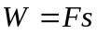 and 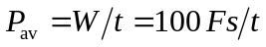 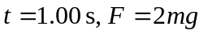and 